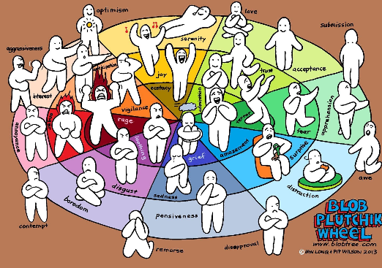
Emotional Intelligence and Communication – Strategies to support students
Date: Thursday 11th May 2023
Time: 4.30pm – 6.00pm
Venue: Carwarden House School, 118 Upper Chobham Road, Camberley, GU15 1EJ
Cost: £20 per person
This training is intended for professionals working with and parents of young people who struggle to express and cope with their emotions

TO BOOK GO TO https://www.carwarden.surrey.sch.uk/outreach

What Are The Blobs? A Feelosophy
The Blobs are simple. They deal with deep issues using the primary languages we learn from infancy – feelings and body language. This is why they are used with children as young as 4, all the way through to the elderly.
The key objectives of the course –
- How to recognise your emotions and communicate these to others
- How to cope with emotions
- Strategies to support students who are struggling to cope with their emotional intelligence
- demonstrate a wide range of tools for use in schools as well as curriculum scales for self-assessment.
"Ian Long is the co-creator of the Blob Tree visual tools. He has been a teacher for 17 years, a youth worker for 6 years and is currently a full time Blob illustrator/author/trainer.
The Blobs are accessible by all ages as there are no words. They are a simple discussion tool to enable deep conversations about feelings.
There will be a range of Blob books and cards available to be viewed, as well as free resources provided.”

